Subject line: (insert title of your video here)
[First Name],
I just recorded this for you.
It’s a free video on (insert title of your video here)
In the video we cover:
-
-
-
Click the image, the button or use this link to watch the video 👇 👇
Click here
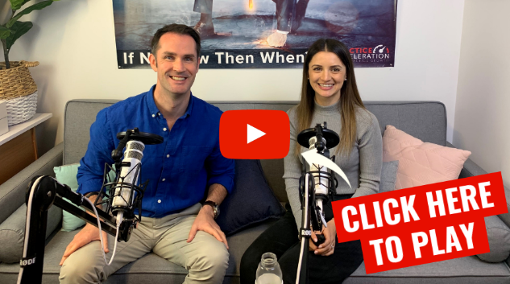
Are you struggling with (insert problem)?
Well, ask me a question underneath the video, and I’ll make sure I answer it for you personally.
I promise I’ll do everything I can to provide value.
Speak soon,
(name)
(image of you here)
P.S: Want to learn more about how we can help you to (achieve outcome or address problem?)
Click here to book a time:
(Link to online bookings)

